

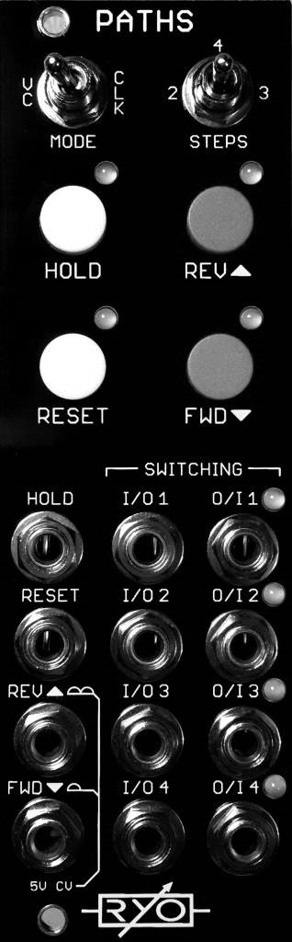

LjunggrenAudio RYO PATHS
A Cycling Sequential Switch

Quickstart – what is Paths and how do I get going?

Paths is a 4:4 cycling sequential switch, featuring simultaneous forward/reverse stepping, hold, reset, and an additional voltage controlled mode based on the same design as our VC Sequencer. Also on board are push buttons for each function enabling you to play and perform with a more hands on style.

This sequential switch will do all your standard 1>2, 1>3, 1>4 or the other ways around with great real-time as well as external voltage controllability.

But its when you start playing around with multiple sources and destinations that things start getting fun and weird! You could for instance shuffle around four different trigger patterns to trigger four different percussive generators for interesting variations, or why not 4 oscillators shuffling between 4 different destinations, panned and processed in various ways?

Whatever your sequential switch application might be, we're confident Paths is up to the task!

Installation

To begin installation, please make sure that:
- you have a standard pinout eurorack bus board
- you have +12V and -12V power rails on that bus board [no +5V supply is required]
- the power rails are not overloaded

!!!Before installing this module disconnect the power from your system!!!

- Double check the polarity of the ribbon cable - The red stripe should be aligned with the -12V rail, on both the module and on the bus board

[we use shrouded headers but it's still possible a cable has been assembled with the stripe on the wrong side of the shroud so always double check!].

Also make sure when using busboards without shrouded headers that the pins aren't transposed a row vertically or horizontally – all pins should insert into holes on the cable.

Although we use both PTC fuses and schottke diodes to provide reverse polarity and excess current protection, we do not take any responsibility for damages caused by wrong power supply connection!
After you have connected everything, double checked it and ensured your case is closed such that no power lines can be touched by your hand or any stray cables drop into holes, turn on your system and test the module

Clocked Mode; When clocking with the FWD clock input or the FWD button the sequence will advance one step forward per pulse. When clocking with the REV clock input or the REV button, the sequence will advance one step in reverse per pulse. If a clock pulse comes in exactly at the same time on both inputs the forward will have priority over the reverse.

CV Mode; In CV mode there is two CV inputs. The one that shares the reverse clock input is full wave rectified and the one that shares the forward clock input is half wave rectified. It uses an active rectifier without voltage drop or a dead zone around 0V.

The half wave rectified (FWD) input, with one bump on the rectifier symbol, will clip any signal below 0V and above 5V. This is different to the full wave rectified input (REV), the one with two bumps on the rectifier symbol, in that it will turn any negative volt into positive as well. So -1V is the same as +1V and -5V is the same as +5V etc.

The CV inputs are mixed together so they can be used at the same time.

The steps toggle switch and the red buttons are inactive in CV mode; To limit the number of steps in CV mode you can use an attenuator to attenuate the CV down to only reach 2 or 3 steps.

Four separate switches; It's essentially four separate switches that are commonly controlled and shares ins and outs.

- When I/O1 is connected to O/I1, I/O2 is connected to O/I2 and so on.
- When I/O1 is connected to O/I2, I/O2 is connected to O/I3 and so on, and I/O4 is connected to O/I1.
- When I/O1 is connected to O/I3, I/O2 is connected to O/I4 and I/O3 is connected to O/I1 and so on.

Just like the RYO VC Sequencer it is clockable to very high clock rates (100kHz tested) and is CVable to full audio range, allowing for all your experimental waveshaping duties.

All the routings can be seen in the picture below, each module represents one of the four steps as the LEDs next to the jacks indicate.

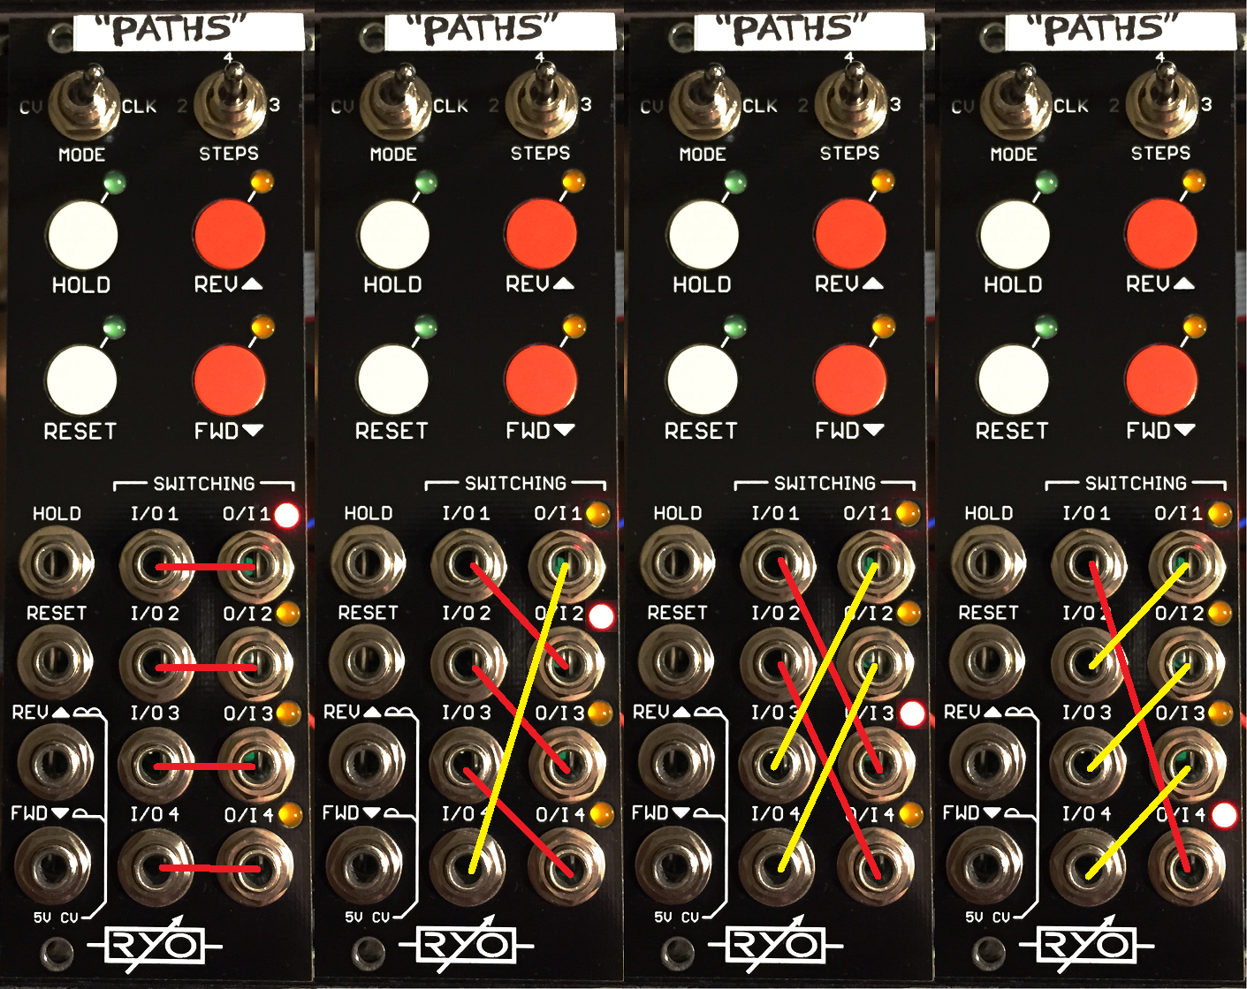

Using 2/4/3 Steps and reverse direction; The toggle switch that controls the number of steps works a little peculiarly due to the CMOS CD4516 counter IC. Reset always takes it back to step 1/first LED lit. We could then choose to always let it reset on steps 3 and 4 respectively for 2 and 3 steps.

But, when run in reverse it would mean that with the toggle switch on 2 steps it would go 2 steps before it hits step 3 and resets. All good so far, but, when 3 steps were selected it would just stay on step 1 when clocked in reverse as step 4 would be next and that would reset it. So we choose to let it reset on step 2 when you run it in reverse so it goes 1 -> 4 -> 3 -> 1.

This opens up the possibility to clock forward and reverse with different triggers or button presses and therefore make it go in controlled irregular patterns. 1 -> FWD -> 2 -> FWD -> 3 -> REV -> 1 -> REV -> 4 -> REV -> 3-> FWD -> 1 as an example. Add a little random trigs or button presses and it will be less controlled.

Two parallel 1:2 switches; You could also patch it like two commonly controlled parallel 1:2 switches if you only run it in one direction. Easiest is forward direction: I/O1 : O/I1 & O/I2 respectively I/O3 : O/I3 & O/I4

Dimensions
Height: 3U (128.5mm)
Width: 8HP (40.30mm)
Depth: 46mm (with power cable attached)

Weight: ???g

Current consumption
+12V rail 30mA
-12V rail 8mA
+5V rail no +5V supply required

Basic specifications
total frequency controllable range dc to 50kHz
max input/output audio signal 20Vpp
CV input range -10V to +10V

Max gain n/a

Nominal impedances
Audio signal input: 430ohm
Audio Signal output: 430ohm
CV input: 22kohm

Patch ideas:

Although uses of sequential switches in patch examples and ideas are found readily online and in some books, and similarly there are those familiar with using the RYO VC Seq perhaps, there are many other less obvious ways to use Paths in patches in your modular rig:

below i've included from some inspiring words to help creation of patches that might be fun; and, as ever, experiment – RYO modules are designed with all necessary protection and fail-safes so you can just start plugging in patch cables and see what happens!

Make complex waveforms;
Try clocking the switch in CV mode with a wave form from (one of the) the same oscillator(s) setup as per the commonly used wavetable/wavescanning use of sequential switches where the inputs are each fed a different waveform and then clocked at audio rates to produce new waveforms.

Create complex sequences;
try using Paths to switch between sequences from multiple sequencers or logic modules/other sources of gates and triggers to produce longer meta sequences. These can be in turn with some extra dividers fed back into the clocking/control of Paths to make complex looping setups.

Insert patch ideas here;
lorem ipsum got no more patch ideas. lorem ipsum got no more patch ideas. Lorem ipsum got no more patch ideas. lorem ipsum got no more patch ideas. Lorem Ipsum got no more patch ideas. lorem ipsum got no more patch ideas. lorem ipsum got no more patch ideas. lorem ipsum got no more patch ideas. lorem ipsum got no more patch ideas. lorem ipsum got no more patch ideas. lorem ipsum got no more patch ideas. lorem ipsum got no more patch ideas. lorem ipsum got no more patch ideas. lorem ipsum got no more patch ideas.

